Fitness Buddy AI - Project Documentation

Home Page
The homepage introduces Fitness Buddy AI, an IBM Granite powered fitness assistant. It provides quick access to Dashboard, Profile, Workout, Nutrition, BMI, Habits and AI Chat. Users can start their fitness journey and view AI-powered features.
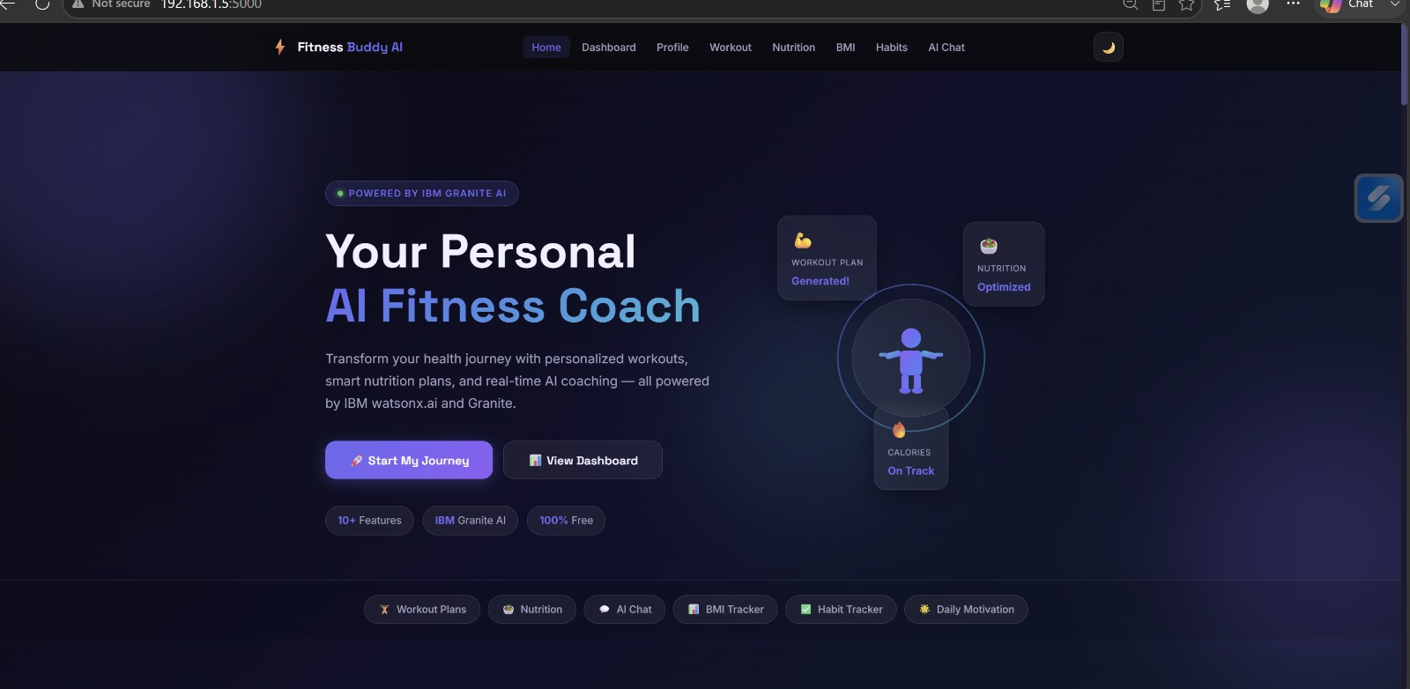

AI Chat
The AI Chat Coach answers questions related to fitness, workouts, nutrition and wellness using IBM Granite AI. It provides personalized guidance and recommendations.
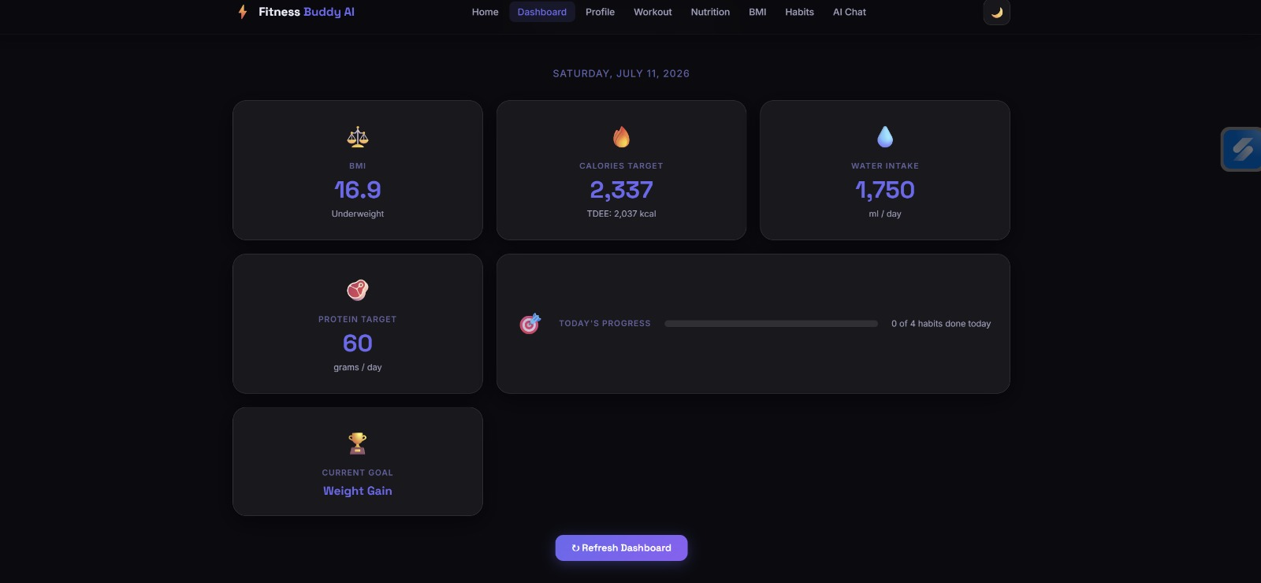

Dashboard
The dashboard displays BMI, calorie target, water intake, protein target, goal tracking and daily progress, giving users a complete health overview.
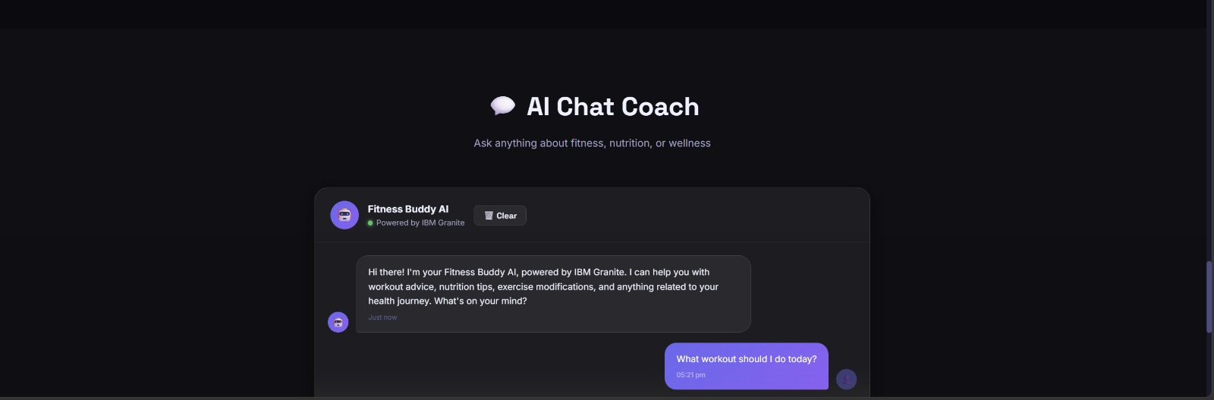

Habit Tracker
The Habit Tracker allows users to mark workout, water intake, sleep and healthy meal completion while monitoring daily progress and receiving AI tips.
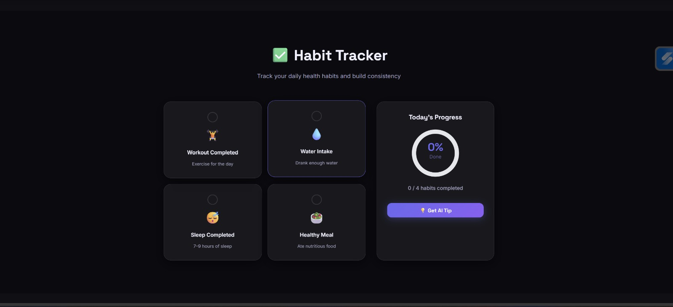

Certificates Earned
IBM SkillsBuild Certificate
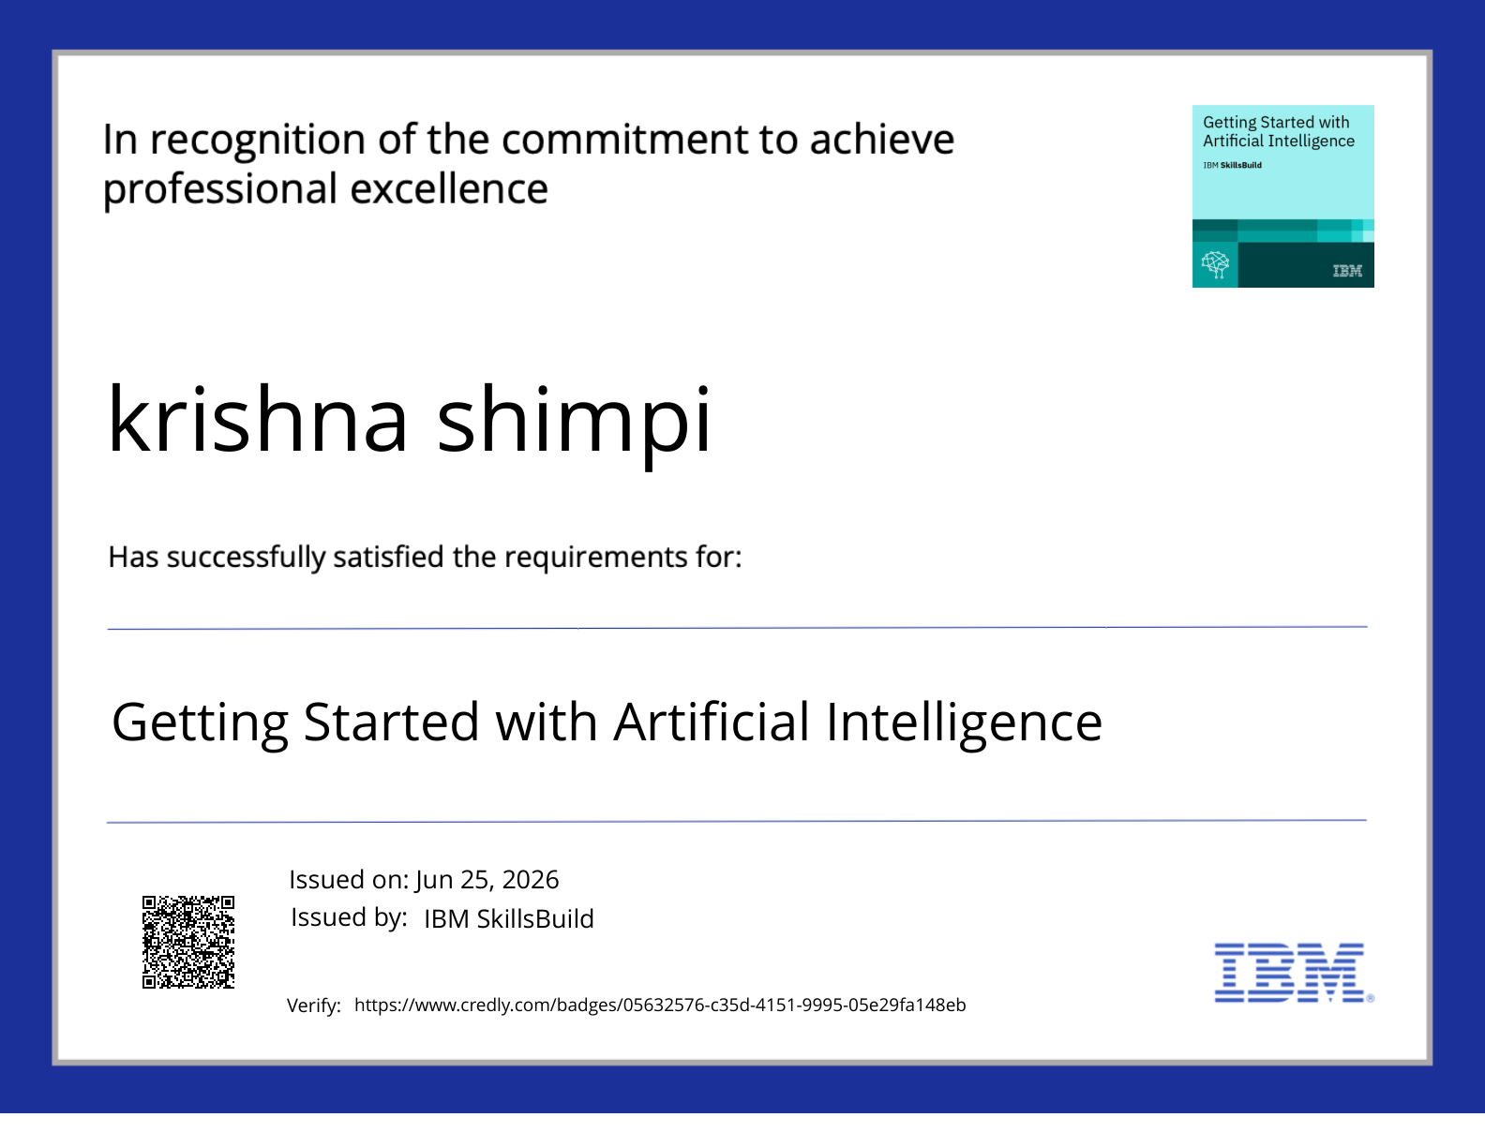
IBM BOB Certificate
Please upload the second certificate as well. I received only one certificate PDF in this message.

